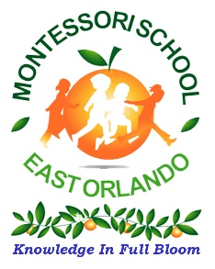
Montessori School of East Orlando
2526 Percival Rd.
Orlando, FL 32826
(407)447-5860 (O)
(407)737-1087 (F)
www.mseastorlando.com
Picture/Video
Authorization Form
2022-2023 School Year

From time to time, photos/videos will be taken of students, student activities, etc. The school reserves the right to use these photos for the school’s website, school related video, slide presentations, marketing purposes, social media, etc.

Click here to enter text.
Student’s Name

☐ Yes, I grant permission for MSEO to use my child’s photo for the publications listed above.

☐ No, please do not use my child’s photo.

Click here to enter text. | Click here to enter a date.
Parent / Guardian Signature | Date

